# Wednesday, October 18

Thank God for new opportunities for youth in **Kazakhstan** to share the Gospel through social media. Our team has received strong responses from people who are interested in faith and church. Pray that more listeners in this country will accept Jesus as their Savior and share the Good News with others.

# Thursday, October 19

In **Vietnam** there are over 20 ethnic language broadcasts available to listeners. Pray for God to guide our team as they create content for three new minority languages this year. Also, pray for the people who speak these languages to hear the Gospel message and accept Christ as their Savior.

# Friday, October 20

Pray for those living in **Laos**, a country just north of Thailand. Laos is one of five remaining communist countries in the world. Pray for FEBC’s digital media

# Sunday, October 22

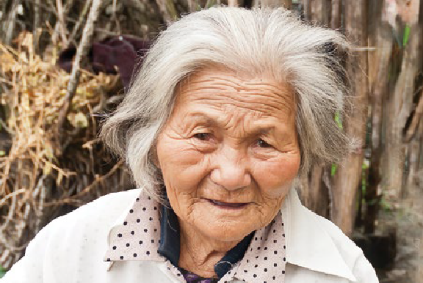

Please pray for FEBC’s mission of proclaiming the saving message of the Gospel to spread to the most remote places in the world. May the Holy Spirit move and saturate the hearts of the people in these places. Pray that listeners will hear and understand broadcasts of the Good News.

# Monday, October 23

Pray for the Lord to encourage our team in **Kyrgyzstan** to effectively reach unreached listeners through radio, internet, and social media. FEBC broadcasters in Bishkek, the

# Wednesday, October 25

Pray for the 1.5 million Yao people in **Malawi.** Please ask for God to focus FEBC’s team as they distribute radios, speak with listeners, and meet with listener clubs.

Also, pray for God to guide the process of expanding our radio network to reach even more Yao with the Gospel.

# Thursday, October 26

More than 228 million people live in the country of **Pakistan** and over 97% practice Islam. The country is also in the midst of economic and political turmoil, which has caused a high inflation rate throughout

the nation. Ask the Lord for His grace and provision and for hearts to be open to learn more about Jesus.

**LISTENER IN KOREA**

“**After years of prayer**, my husband and sister heard the Gospel (through your program)

and accepted Jesus as their Savior.

**FEBC is a missionary for my family!**”

# Sunday, October 29

Take a moment to thank God and praise Him for the millions of people all over the world who have tuned into FEBC today and heard the Good News. Thank the Lord for the seeds that have been planted, and for those who have accepted Jesus Christ as their Savior! May the Gospel continue to be proclaimed… until all have heard.

# Monday, October 30

Please pray for the 443 unreached people groups in **China.** A listener shared: “Your programs opened my eyes to let me realize there are Christians all over the world. Now, I no longer reject it.” Pray for more people in China to hear the Good News and embrace Christianity, just like this listener.

# Tuesday, October 31

Pray for people in **India.** Ask the Lord for energy, creativity, and good health for FEBC broadcasters to share the hope and peace of Jesus. May the Holy Spirit bring an increase in new listeners as well.

opportunities to increase as smartphones

capital city, have received threats by Muslim

become more accessible. May the Gospel reach those who are seeking truth and continue to spread to the unreached.



*YOUR DAILY PRAYER GUIDE FOR THE UNREACHED*

OCTOBER 2023

**PRAYER**

T A R G E T

# Saturday, October 21

Please pray for the unreached people living in **Cambodia.** May listeners experience the peace of Christ and be moved to share the Gospel with family and friends. Pray for the new radio tower being built, that all will go smoothly with construction.

extremists. Pray for the Lord’s protection over this team as they share the Good News with boldness.

# Tuesday, October 24

As conflict continues with **Russia** and **Ukraine,** pray for peace to prevail in the hearts and minds of country leaders. Also, please pray for FEBC’s team in eastern Ukraine who provide counseling, prayer, and the message of hope to thousands each month through a telephone helpline.

# Friday, October 27

Pray for FEBC’s team as they boldly share the Good News in **Central Asia.** May the Holy Spirit provide spiritual discernment and move in the hearts of those who are in need of everlasting hope.

# Saturday, October 28

Please pray for the Hmong people living in **Southeast Asia.** Many listeners there receive and share radios with their villages. May the power of Jesus shine throughout these village communities and beyond.

To learn more or make a donation, visit [**febc.org**](https://www.febc.org/)or call **800-523-3480**.

Please send all mail donations to our FEBC National Processing Center, PO Box 6020, Albert Lea, MN 56007.

[](http://febc.org/stories) [febc.org/stories](http://febc.org/stories) [twitter.com/febcusa](http://twitter.com/febcusa) [](http://facebook.com/febcusa) [facebook.com/febcusa](http://facebook.com/febcusa)

[youtube.com/fareastbroadcasting](http://youtube.com/fareastbroadcasting)

**FAR EAST BROADCASTING COMPANY**

PO Box 1, La Mirada, CA 90637-0001

800-523-3480 | *febc.org*

# Sunday, October 1

Thank the Lord for opportunities to reach people in **North Korea.** Despite religious restrictions, the Gospel message is reaching the lost in this country. Pray for even more people to come to know Jesus as Savior and Lord.

# Monday, October 2

With religious intolerance on the rise, pray for the people of **Pakistan.** Please pray for the safety of FEBC’s staff, local ministries, and churches. Ask for God’s protection as believers continue to share the love of Christ with others.

# Tuesday, October 3

Pray for the people of **Taiwan.** The government has lifted restrictions to allow for communities

# Friday, October 6

Praise God! Listeners in **Indonesia** are sharing that they are learning more about God and the sacrifice of Jesus on the cross. In this country, many people groups remain unreached—about 63% of the total population. Pray for our broadcasters to be filled with the Holy Spirit and for more lives to be changed by the Gospel.

# Saturday, October 7

Today, pray for those living in the **Philippines** who have never heard the Gospel in their heart language. May the Lord guide our local team to the right locations as we plan to build and operate new radio stations — to reach even more with the Good News!

# Tuesday, October 10

Pray for God’s protection within **China,** including our team and colleagues in Hong Kong. FEBC is using AM signals to reach the people on the southeast coast and also developing a new mobile platform. Pray for God to continue to use our efforts to spread

# Saturday, October 14

Praise God! In **India** there are 283 million people who can hear the Gospel through FEBC radio programs in eight languages. Ask the Lord to provide direction and creative collaboration for our producers and staff to reach even more listeners who speak other languages.

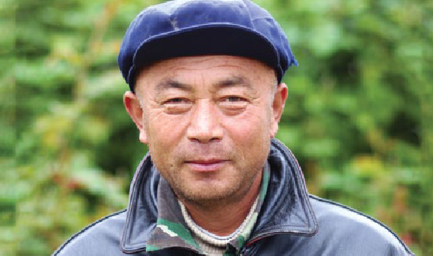

# Sunday, October 15

Religious radio stations are not allowed on the ground in **Japan.** Therefore, FEBC programs are transmitted into Japan from **South Korea.** These programs are some of the only Christian broadcast media available to listeners there. Pray for believers to feel strengthened by God’s

to be more open. Ask the Lord to use FEBC’s

**LISTENER IN CHINA**

team as they broadcast new children and youth

the Gospel and make disciples in this country.

love and encouraged to share this hope

with others.

programs to reach the next generation with the love of Jesus.



**PRAYER**

IMPACT

Thank you for praying and interceding for FEBC listeners around the world. I’m so grateful for you!

Ed

*“I came to know God while in prison.* ***I thank***

***the Lord that I got to study His Word (through listening to FEBC), teaching me hope and encouragement*** *to keep on fighting as I wait*

*for the day I receive my freedom.”*

* **Listener in Thailand**

*“Listening to FEBC fills me with joy!* ***I feel the presence of God.*** *I once thought I would be better off dead, but even then,* ***FEBC was my guidepost*** *and encouragement. So FEBC is my lifesaver!”*

* **Listener in Japan**

*“****Please continue to send God’s Word.*** *Your messages give us hope and they’ve led thousands to the Lord.* ***No missionary can reach us in the mountains, but FEBC can!*** *Your programs are very important. We wait for them daily.”*

* **Hmong Listener**

# Wednesday, October 4

Please pray for local churches in **Thailand** and opportunities for them to partner with FEBC’s team. Ask God to strengthen these relationships and for more people to engage with our Bible programs, including new content for the Thai people living in the southern region.

# Thursday, October 5

Pray for pastors living in **Ukraine** to be encouraged and strengthened. Ask for endurance as they share the Good News amidst the chaos and destruction. Some have chosen to remain in place despite the danger and

are walking the streets of their communities, ministering to anyone they find, proclaiming the message of “Immanuel – God is with us!”

“I have been a listener of FEBC for many years. **God’s words have taken root in my heart** and my life is renewed by your nurturing.

Thank the Lord!”

# Sunday, October 8

Please pray for churches around the world. FEBC strives to partner with local churches and help new believers grow in their faith. Pray for our partnerships to be strengthened. May Christians experience discipleship and community along with a desire to reach others who are unreached.

# Monday, October 9

Tropical storm Ana severely impacted five FEBC stations in **Mozambique** and **Malawi.** Please pray for our team as they continue to rebuild and make adjustments to continue broadcasting the Gospel to the unreached communities in this area.

# Wednesday, October 11

Thank God for FEBC’s successful partnerships in **Mongolia.** Three new stations will soon go on the air! May the broadcasts from these new locations lead thousands of people in Mongolia to discover the saving love of Jesus Christ.

# Thursday, October 12

Please pray for the unreached people of **Chad.** As political unrest continues, ask the Lord to anoint the pastors and churches who partner with FEBC as they share the Good News with those who are suffering and afraid.

# Friday, October 13

Pray for God to guide our efforts to reach **Myanmar.** With military conflict still sweeping the country, FEBC’s broadcasts offer messages of hope to people living there. Pray for those who may be hearing the message of Jesus for the first time to place their trust in Him.

# Monday, October 16

Because of your faithful partnership, FEBC continues to share the Gospel boldly, grow indigenous leaders, and use advancing technology to reach the unreached. Pray for more people to discover the love of Jesus, like this

listener in Thailand, who shared: *“When I invited God into my heart, many changes happened. My worries were relieved.*

*Thank God for the salvation given to me!”*

# Tuesday, October 17

Please pray for Inna, a broadcaster for FEBC **Ukraine.** Pray for Inna to have wisdom and discernment as she leads weekly prayer meetings and for listeners all over the country to develop strong relationships with God.