OCTOBER 2022

PRAYER
T A R G E T

ENCOURAGEMENT
FROM ED

“Again, I tell you that if two of you on earth agree about anything you ask for, it will be done for you by my Father in heaven. For where two or three come together in my name, there am I with them.” Matthew 18:19-20

We are dependent on prayer to see the Kingdom of the Lord established and we rely on prayer to see doors open for the message of the Gospel.
Here in this passage of Matthew, Jesus

Saturday, October 1
Please pray for God to guide and direct our efforts to reach Myanmar. With military conflict still riveting the country, FEBC’s broadcasts offer messages of hope to people living there. Pray for those who may be hearing the message of Jesus for the first time to place their trust in Him.

Sunday, October 2
Pray for the people of Taiwan. The government has lifted restrictions to allow for communities to be more open. Ask the Lord to use FEBC’s team as they broadcast new children and youth programs to reach more listeners in the days ahead.

Monday, October 3

Thursday, October 6
Praise God! In India there are 283 million people who can hear the Gospel through FEBC radio programs in eight languages. Ask the Lord to provide wisdom and creative collaboration for our producers and staff to reach even more listeners who speak other languages.

Friday, October 7
Thank God for FEBC’s successful partnerships in Mongolia. Three new stations in the west recently launched and two more are planned to launch in the fall. May the broadcasts from these new locations lead thousands of people in Mongolia to discover the saving love of Jesus Christ.

Sunday, October 9
Praise God for the successful Give a Radio campaign in the Philippines. Pray for FEBC’s team as they coordinate delivering the
A Mother Encouraged in Kyrgyzstan

teaches His disciples about the powerful
impact that happens when they come together in prayer. And He promises that
Please pray for the Hmong people living in
Southeast Asia. Many listeners there receive and share radios with their villages. May the

“I AM A YOUNG MOTHER AND
radios to the unreached people groups and communities. May the life-changing message of Jesus spread far and wide in this country.

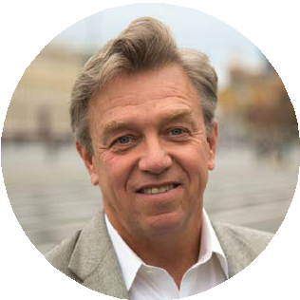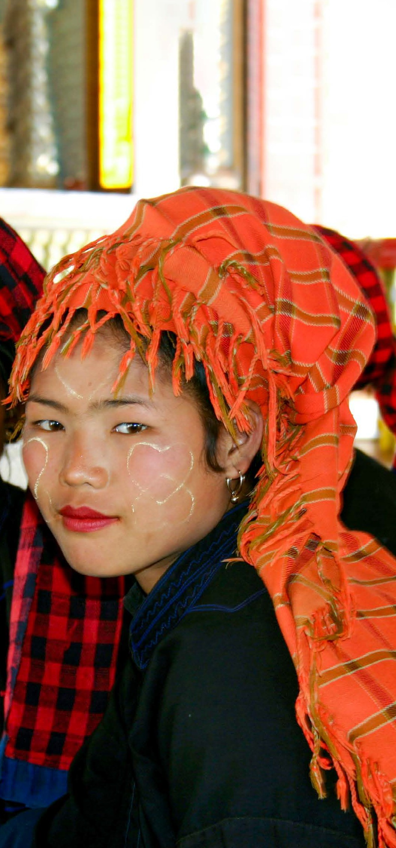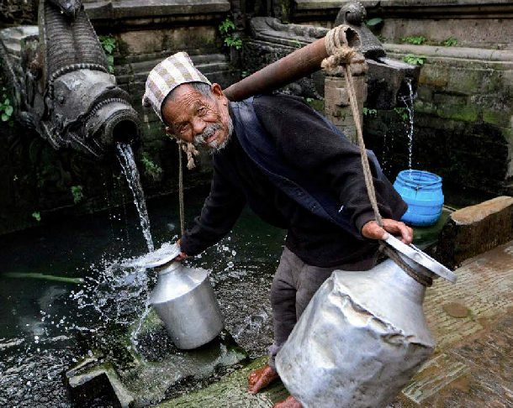

YOUR DAILY PRAYER GUIDE FOR THE UNREACHED
He will be there with them.
What an amazing promise that continues today! As we come humbly before the Lord… He is with us.
As you pray daily through the Prayer Target, you can be assured that you are not praying alone. There are many other faithful ministry partners, lifting the same needs to the Father in prayer… now that’s a mighty team of prayer warriors!
Be encouraged as you pray! The Lord is creating incredible opportunities and opening doors for the Gospel to be heard around the world.

Until all have heard,

Edward W. Cannon
President and CEO
light of Jesus shine throughout these villages and beyond.

Tuesday, October 4
Please pray for our ministry directors and FEBC staff all over the world. These dedicated leaders face challenges every day to reach the unreached. Ask the Lord to provide strength, wisdom, and direction.

Wednesday, October 5
With religious intolerance on the rise, pray for the people of Pakistan. Please pray for the safety of FEBC’s staff, local ministries, and
churches. Ask for God’s protection as believers continue to share the love of Christ with others.
STRUGGLE WITH LACK OF CONFIDENCE. IN YOUR BROADCASTS YOU TALK ABOUT THE IMPORTANCE OF PASSING ON GODLY CONFIDENCE TO OUR CHILDREN.
WITH GOD’S HELP WE ARE ABLE TO DO GOOD. THANK YOU FOR THE ENCOURAGEMENT!”

Saturday, October 8
Pray for the 1.5 million Yao people in Malawi. Please ask for God to focus FEBC’s team as they distribute radios, speak with listeners, and meet with listener clubs.
Also, pray for God to guide the process of expanding our radio network to reach even more Yao with the Gospel.

Monday, October 10
Pray for the Lord to encourage our team in Kyrgyzstan to effectively reach unreached listeners through radio, internet, and social media. FEBC broadcasters in Bishkek, the capital city, have recently received threats by Muslim extremists. Pray for the Lord’s protection over this team as they share the Good News with boldness.

Tuesday, October 11
Religious radio stations are not allowed in Japan. Therefore, FEBC programs are transmitted into Japan from South Korea. These programs are some of the only Christian broadcast media available to listeners there. Pray for believers to feel renewed by God’s love and encouraged to share this hope with others.

Wednesday, October 12
Today, take a moment and pray for our listeners in Chad. Given the political unrest in this region, pray for safety of our staff and the surrounding communities.
May the message of the Gospel speak to the hearts of the people in this country.

Thursday, October 13
In Vietnam there are many ethnic language broadcasts available to listeners. Please pray for the people who speak these languages to hear our programs and come to a saving faith in
Christ. Also, pray for the many programs produced in Vietnamese.

Sunday, October 16
Pray for FEBC’s team as they share the Good News in sensitive areas like Northeast Africa. May the Holy Spirit
provide spiritual discernment and move in the hearts of those who are victims of violence and unrest.

Monday, October 17
Please pray for God’s protection within China, including our team and colleagues in Hong Kong. Despite the severe
impact of COVID-19, FEBC’s online programs have hit a record high of play and downloads from listeners. May the Gospel message expand to more and

Thursday, October 20
Please pray for Kazakhstan after the political unrest with protests and destruction of government buildings earlier this year.
Continue to pray for our team in the capital city of Almaty and for FEBC’s broadcasts to minister to listeners who may be more open to God during these difficult times.

Friday, October 21
As conflict continues with Russia and Ukraine, pray for peace to prevail in the hearts and minds of country leaders. Also, please pray for FEBC’s team in eastern Ukraine who provide counseling, prayer, and the message of hope to thousands each

Tuesday, October 25
Please pray for local churches in Thailand and opportunities for them to partner with FEBC’s team. Ask God to strengthen these relationships and for more people to engage with our Bible programs, including new content for the Thai youth on YouTube.
A Cambodian’s Life Saved
“MY LIFE HAS BEEN FULL OF PROBLEMS AND DESPAIR. BY LISTENING TO THE SHORTWAVE RADIO, I LEARNED OF GOD’S MERCY AND LOVE. HE HEALED MY BROKEN HEART AND I DECIDED TO WALK IN HIS WAYS AND ACCEPT JESUS AS MY SAVIOR.”

Saturday, October 29
Because of your partnership, FEBC continues to share the Gospel boldly, develop indigenous leaders, and use advancing technology to reach the unreached. May the Lord continue to provide the resources to expand the reach of this ministry…until all have heard!

Sunday, October 30
Please pray for Inna, a broadcaster for FEBC
Ukraine. Pray for Inna to have wisdom and discernment as she leads weekly prayer
meetings and for listeners in places like Lviv to develop strong relationships with God.
See more FEBC Ukraine staff prayer requests at FEBC.org.

Friday, October 14
more people in this country.
month through a telephone helpline.

Monday, October 31

Please pray for Ukrainian pastors to be encouraged and strengthened. Ask for boldness as they share the Good News amidst the chaos and destruction. Some have chosen to remain in place despite the danger and are walking the streets of their communities, ministering to anyone they find, proclaiming the message of “Immanuel – God is with us!”

Saturday, October 15
Today, please pray for churches around the world. FEBC strives to partner with local churches and help new believers grow in their faith. Pray for our partnerships to be strengthened. May Christians experience discipleship and community along with a desire to reach others who are unreached.

Tuesday, October 18
Pray for those living in Laos, a country just north of Thailand. Laos is one of five remaining communist countries in the world. Pray for FEBC’s digital media opportunities to increase as cell phones become more accessible. May the Gospel reach those who are seeking truth and continue to spread to the unreached.

Wednesday, October 19
Praise God! Listeners in Indonesia are sharing feedback they are learning more about God and the sacrifice of Jesus on the cross. In this country, many people groups remain unreached—about 63% of the total population. Pray for our broadcasters to be filled with the Holy Spirit and for more lives to be changed by the Gospel.

Saturday, October 22
Please pray for FEBC’s mission of proclaiming the saving message of the Gospel to spread to the most remote places in the world. May the Holy Spirit move and saturate the hearts of the people in these places. Pray that listeners will hear and understand broadcasts of the Good News.

Sunday, October 23
Pray for people in India and those still suffering from COVID-19. Ask the Lord for endurance, creativity, and good health for FEBC broadcasters to share the hope and peace of Jesus. May the Holy Spirit bring an increase in new listeners as well.

Monday, October 24
Tropical storm Ana severely impacted five FEBC stations in Mozambique and Malawi.
Please pray for our team as they rebuild the damaged areas and make adjustments to continue broadcasting the Gospel to the hurting communities in this area.

Wednesday, October 26
More than 228 million people live in the country of Pakistan and over 97% practice Islam. Please pray for eyes to be opened and hearts to be willing to learn more about Jesus. May a multitude of people in this country embrace a relationship with Him.

Thursday, October 27
Thank the Lord for opportunities to reach people in North Korea. Despite religious restrictions, the Gospel message is reaching the lost in this country. Pray for even more people to come to know Jesus as Savior and Lord.

Friday, October 28
Please pray for the unreached people living in Cambodia. May listeners experience the peace of Christ and be moved to share the Gospel with family and friends. Pray for the new radio tower being built, that all will go smoothly with construction.
Please pray for the 443 unreached people groups in China. A listener shared: “Your programs opened my eyes to let me realize there are Christians all over the world. Now, I no longer reject it.” Pray for more people in China to hear the Good News and embrace Christianity, just like this listener.

To learn more or make a donation, visit febc.org or call 800-523-3480.

febc.org/stories twitter.com/febcusa
facebook.com/febcusa
youtube.com/ fareastbroadcasting

FAR EAST BROADCASTING COMPANY
PO Box 1, La Mirada, CA 90637-0001
800-523-3480 | febc.org

