PrayerTarget Monday, June 1 – A few weeks ago in

“Rejoice in hope, be patient in tribulation, be constant in prayer” (Romans 12:12 ESV).
We are seeing unprecedented numbers of unreached souls throughout Asia and around the world tuning into FEBC broadcasts. They are desperately looking for comfort and hope in the midst of the coronavirus pandemic.
I believe God is preparing these hearts to receive Him, to replace their fear with hope for this life and for all eternity.
As you join with us in praying for the daily prayer requests this month, please unite with us in prayer that…
- God will keep FEBC broadcasts on the air to deliver the Gospel to those who are seeking Him.
- FEBC staff can continue to answer every urgent Kingdom question and bring these hurting souls to faith in Christ.
- This global health crisis will spur a great harvest of souls who may otherwise live and die without knowing of Jesus’ infinite love and sacrifice.
Thank you for your commitment to pray with us…we are trusting in God’s promise to be in our midst as we seek Him, together, in fervent prayer for the unreached!
Until all have heard,

Edward W. Cannon
President and CEO
Mozambique, dangerous Jihadists overtook two
large towns and threatened to invade the city where FEBC is located. Please pray that any future violent efforts will be thwarted. Pray for the safety of the people in this region and that our Gospel programs will impact listeners.
Tuesday, June 2 – A listener from Japan writes: “I have been listening to FEBC since the 2011 earthquake. Your programs give me the
encouragement I need each day. Now I have faith!” Responses like this are so encouraging! Please pray for many more to tune into our programs and find new life in Jesus Christ.
Wednesday, June 3 – As a member of the Hmong ethnic people group of Southeast Asia, Pao struggled with persecution and injustice, so hearing the Israelite’s story of deliverance through an FEBC broadcast resonated with him. He believed God could be his deliverer so Pao gave his life to Christ. His transformation eventually led to his entire village dedicating themselves to Jesus! Pray that many more will tune in and give their hearts to Jesus.
Thursday, June 4 – In Russia, Natalia is an experienced prison worker; she also hosts an FEBC program that ministers to prisoners and their families. While this group of people are often overlooked, God cares about them. Please pray that
many will tune into Natalia’s programs and discover the grace and mercy of Jesus.
Friday, June 5 – Please pray for people around the world impacted by COVID-19. Pray for families who lost loved ones, for business owners who lost their livelihoods, and the work force who lost their jobs due to government-mandated shutdowns. Pray for restoration. Most importantly, pray that people will
turn to Jesus Christ and accept Him as Lord and Savior.

Saturday, June 6 – Pray the Lord will continue to give wisdom and discernment to FEBC leadership as we work to share the Gospel with the nations.
Sunday, June 7 – FEBC’s on-air Liangyou Theological Seminary in China has over 17,000 students enrolled. Pray for each student, many who are already pastoring, that this intense two-year program will strengthen biblical knowledge and pastoral skills.

“I record your programs every day and listen to them repeatedly. God has transformed my life.”
Listener in China

Monday, June 8 – Repairing and replacing broadcasting equipment in studios and offices keeps the Good News on the air. Pray for this vital aspect of FEBC’s ministry, and that the Lord will provide the funds needed.
Tuesday, June 9 – FEBC currently shares the Good News in 86 ethnic languages, 52 of which are broadcast via shortwave radio. As you read this
request, the Gospel is being proclaimed. Pray hearts will be touched and many will accept the free gift of salvation through Jesus Christ.
Wednesday, June 10 – Kamolthip, an FEBC broadcaster serving in Thailand, told us: “It is my privilege to bring people to God. I make myself
a bridge of love for people to walk across to the Lord.” Pray for our entire team in Thailand, a Buddhist-dominant nation where most people worship at the feet of Buddha statues. Pray that hearts will be reached for Jesus.

Thursday, June 11 – People around the world are searching for hope, especially during
Covid-19. We know that “hope” can only be found in Jesus Christ. Pray the Lord will especially anoint our broadcasters today and help them as they share the Good News with the nations.
Friday, June 12 – Our studio in Chad (central Africa) officially launched their first broadcasts in December 2019. Testimonies are already streaming in. Apart from radical Islam,
corruption and poverty are very serious problems here. Please pray that many will tune into this new station and hear the Gospel message.
Saturday, June 13 – The ongoing war in eastern Ukraine is inflicting great suffering. People on both sides of the conflict are responding to our broadcasts. Please pray for hearts to be open to the Word of God.
Sunday, June 14 – Pray for the staff of FEBC Cambodia as they travel to remote villages to distribute Gospel Speaker Boxes. These digital Speaker Boxes provide Christian teaching on memory cards, holding hours of biblical material. Pray for a harvest of souls.
Monday, June 15 – In several countries, FEBC has developed creative children’s programming. This is especially important in China, because authorities have prohibited children 0-18 from attending Christian churches. Please pray that these programs will reach receptive hearts with the Good News.
Tuesday, June 16 – At one time, Siberia was a place of exile for Russian Christians, but today an active church exists here. FEBC currently partners with 7 stations in this northern most region of Russia. Pray for changed hearts here.

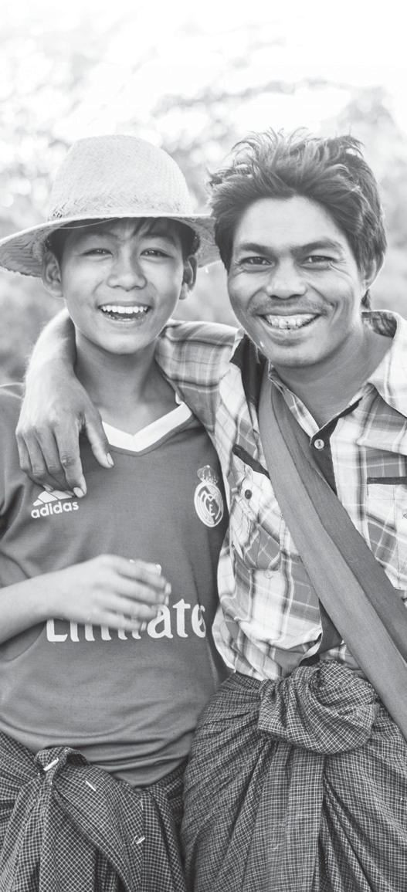Wednesday, June 17 – A listener from Kyrgyzstan shared: “The death of my father was very stressful to me. I lost all confidence in myself. Basically, my life became a disaster. Recently I started listening to your station. You’ve managed to bring me back to life. I think the major change came from putting my trust in God. Thank you!” Please pray that this listener will continue to tune into our programs and grow spiritually.
PRAYER TARGET
June 2020
“Rejoice in hope, be patient in tribulation, be constant in prayer” (Romans 12:12 ESV).
Thursday, June 18 – Pray for the millions who lost their jobs during the coronavirus pandemic. Pray that businesses will rebound and people can get back to work. Pray that the economies of the world will bounce back quickly.
Friday, June 19 – Our team in Pakistan uses social media to follow up with listeners who have questions or request prayer. Please pray for the relationships being built through broadcasters and listeners.
Saturday, June 20 – “Your Bible correspondence course established my faith, and now I serve in my village,” writes a listener from Thailand. In several countries, FEBC offers a Bible Correspondence Course. Thousands are signed up and complete weekly Bible studies.
Thank God for this outreach that has impacted the lives of many. Pray for a richer understanding of who God is.
Sunday, June 21 – Praise God for the wonderful connections that are made through FEBC programs in India. Pray for our team as they spend time visiting listeners and encouraging them in their faith.
Monday, June 22 – Pray for persecuted believers in Vietnam; they stand out as different from other villagers who practice ancestral worship. Pray that FEBC’s ethnic language broadcasts will be an encouragement to them and for courage as they face oppression.
Tuesday, June 23 – In the 1990s, Oleg came to know Christ through FEBC. Now he is a
broadcaster and key leader of our Ukraine team. Pray for Oleg and his staff as they talk about life and death and important things like a belief in God. Pray for a great harvest in Ukraine.

“I tell my friends about your ministry and many have started listening too!”
Listener in Russia

Wednesday, June 24 – Pray for our teams who work tirelessly to reach the unreached with the Good News of Jesus. Pray for creativity and innovation as they seek to reach some of the hardest to reach areas in the world.
Thursday, June 25 – Pray for the leadership and staff of FEBC Myanmar as they have faced significant challenges and are looking to God to move forward in even greater ways in 2020.
Friday, June 26 – Pray for our teams who focus on reaching into restricted countries. Pray for wisdom and protection as they overcome political and religious barriers to share the truth of Christ.
Saturday, June 27 – In Malawi, FEBC is reaching the Yao, a Muslim group who are responding to our broadcasts, such as this listener: “Today we would like to thank God for your radio programs. I came to know Christ by listening. Your broadcasts have changed many
Yao lives. We now know the truth about Jesus Christ. And we have also testified to our friends and they, too, have received Him into their lives to be their Savior. I am very grateful that FEBC shares the Word of God, which has given us life eternal.” Pray for the Yao!
Sunday, June 28 – Please pray for the spiritual growth of our listeners, such as this man who wrote: “When I listen to your station for an entire day, it’s like attending a day-long seminar, because there are so many lessons to be learned. Most importantly, your programs provide education for spiritual and emotional growth.”
Monday, June 29- Pray for the people of Moldova who can now hear FEBC broadcasts on 7 FM stations. Pray for hearts to be softened and lives to be changed through faith in Jesus Christ.
Tuesday, June 30 – FEBC distributes thousands of radios annually to people in need of hope. Please pray that we can raise sufficient funds to restock our radio supply for the year ahead.

To make an online donation go to:
febc.org/give
To view recent FEBC newscasts, go to:
febc.org/news
To learn more, visit febc.org
or call (800) 523-3480.
febc.org/stories twitter.com/febcusa
facebook.com/febcusa youtube.com/fareastbroadcasting

